Chapter 4: Experimental Results and Discussion

4.2 Chest Disease Classification Experiments

4.2.1 Implementation Environment and Development Tools
This section documents the hardware infrastructure, software environment, and development frameworks employed throughout the experimental evaluation of the proposed chest disease classification system. Reproducibility of results depends critically on the precise specification of the computational environment, and accordingly all relevant configurations are reported below.

Hardware Environment
All centralized training experiments (preprocessing, U-Net segmentation, DenseNet121, ResNet50V2, EfficientNet, and VGG-19 classification models) were conducted on a cloud-based GPU accelerated computational environment with the following specifications:
Table 4.1: Hardware specifications for centralized training experiments.
Component | Specification
Compute Platform | Google Collaboratory (Colab Pro)
GPU | NVIDIA Tesla T4 (15 GB GDDR6)
CPU | Intel Xeon (2 vCPUs, up to 12 CPUs for Ray simulation)
System RAM | 12–51 GB (depending on Colab tier)
Storage | Google Drive (15 GB free / 100 GB+ Pro); mounted via FUSE
Operating System | Ubuntu 20.04 LTS (Colab VM)
The Federated Learning simulation experiments required more intensive multi-process resource management due to the Ray-based client parallelism used by the Flower framework. Resources were allocated per client using Ray's resource reservation mechanism, as detailed in Section 4.2.5.

Software Frameworks and Libraries
The implementation stack is summarized in Table 4.2. All dependencies were installed within the Colab environment, with version pinning applied where reproducibility was critical.
Table 4.2: Software framework and library stack.
Library / Framework | Version / Source | Purpose
Python | 3.10 | Primary programming language
TensorFlow / Keras | 2.15.1 | Centralized model training (U-Net, DenseNet, ResNet, EfficientNet, VGG)
PyTorch | 2.1.0 | Federated Learning model backbone (DenseNet121)
Torchvision | 0.16.1 | Pre-trained model weights, image transforms
Flower (flwr) | 1.4 (simulation) | Federated Learning framework (FedAvg strategy)
Ray | 2.1 | Distributed simulation backend for Flower
OpenCV (cv2) | 4.8.2 | Image preprocessing (CLAHE, Gaussian blur, normalization)
NumPy | 1.24.0 | Numerical computation
scikit-learn | 1.3.0 | Classification reports, confusion matrices, AUC computation
Matplotlib | 3.7.1 | Training history plots, visualization
tqdm | 4.66.1 | Training progress bars
Pandas | 2.0.2 | Misclassification analysis and CSV export

Development Workflow
All experiments were developed iteratively in Jupiter Notebooks within the Google Colab environment, with datasets mounted from Google.
The local preprocessing pipeline (CLAHE, Gaussian blur, normalization) was executed on a local machine equipped with an NVIDIA GPU and then the resulting processed dataset was uploaded to Google Drive for cloud-based training. Model checkpoints, final weights, and evaluation artefacts were saved both locally and to Drive for persistence across Colab session resets.
Mixed precision training (float16 for computations, float32 for master weights) was enabled throughout using TensorFlow's for TensorFlow experiments, providing approximately
2–3× speed improvement on Tensor Core-equipped NVIDIA GPUs with negligible accuracy impact.

4.2.2 Dataset Preparation and Experimental Setup

Dataset Splits and Class Distribution
The full composite dataset of 17,637 images was partitioned into training, validation, and test sets. The training set (15,229 images) was used exclusively for gradient-based parameter updates. The validation set was used for early stopping, learning rate scheduling, and model selection. The test set was kept strictly held out throughout all training and validation activities and was accessed only once for final performance evaluation.
Table 4.3: Complete dataset split and class distribution across all three partitions.
Class | Train | Validation | Test | Total
Normal | 4,870 | ~610 | ~610 | ~6,090
Pneumonia | 4,221 | ~528 | ~528 | ~5,277
COVID-19 | 3,192 | ~400 | ~400 | ~3,992
Tuberculosis | 2,946 | ~368 | ~368 | ~3,682
Total | 15,229 | ~1,906 | ~1,906 | ~19,041
Note on Class Imbalance: The training set exhibits a moderate class imbalance, with Normal (32%) substantially over-represented relative to Tuberculosis (19.3%). Inverse-frequency class weights are applied during training for all models to counteract this imbalance and prevent the classifier from developing a bias toward more frequent classes.

Data Augmentation Strategy
Online data augmentation is applied exclusively to the training set using Keras's ImageDataGenerator API (for TensorFlow experiments) and torchvision.transforms (for Federated Learning experiments). The augmentation policy was carefully selected to apply only transformations that are plausible within the domain of chest radiography — preserving diagnostic realism while increasing data diversity. The augmentation parameters are:
Table 4.4: Data augmentation parameters applied to the training set.
Augmentation | Parameter | Justification
Random rotation | ±15° | Simulates slight patient rotation during positioning
Width shift | ±10% of width | Simulates lateral patient translation on table
Height shift | ±10% of height | Simulates cranio-caudal positioning variation
Zoom | ±10% | Simulates variation in source-to-image distance
Horizontal flip | Yes (p=0.5) | Chest is approximately bilaterally symmetric
Fill mode | Constant (zero fill) | Avoids introducing artefactual texture at image borders
Notably, vertical flipping is excluded (as inverted chest radiographs are not clinically realistic) and brightness/contrast jitter is excluded (as CLAHE preprocessing has already optimized the intensity distribution). Augmentations are applied only at training time; validation and test generators apply only the rescaling operation.

Class Weighting
To further address class imbalance beyond augmentation, inverse-frequency class weights are computed from the training set label distribution and passed to the model's fit() call. For each class $k$:
$$w_{k}=\frac{N_{\text{total}}}{K⋅N_{k}}$$(4.1)
where $K=4$, $N_{\text{total}}=15,229$, and $N_{k}$is the number of training samples of class $k$. The computed weights for the training set are approximately:
Table 4.5: Computed class weights for training.
Class | N_{k} | Weight w_{k}
Normal | 4,870 | ~0.78
Pneumonia | 4,221 | ~0.90
COVID-19 | 3,192 | ~1.19
Tuberculosis | 2,946 | ~1.29

Evaluation Metrics
Model performance is evaluated using a comprehensive set of metrics reflecting both overall and class-specific diagnostic performance:
- Accuracy: $\text{Acc}=\frac{TP+TN}{TP+TN+FP+FN}$— overall proportion of correct predictions.
- Precision (Positive Predictive Value): $P_{k}=\frac{TP_{k}}{TP_{k}+FP_{k}}$— fraction of positive predictions that are correct.
- Recall (Sensitivity): $R_{k}=\frac{TP_{k}}{TP_{k}+FN_{k}}$— fraction of true positives correctly detected.
- F1-Score: $F1_{k}=\frac{2P_{k}R_{k}}{P_{k}+R_{k}}$— harmonic mean of precision and recall.
- AUC-ROC: Area under the Receiver Operating Characteristic curve (for OVR models, evaluated per class and macro-averaged).
- Confusion Matrix: A $4×4$matrix showing the breakdown of correct and incorrect predictions across all class pairs.

4.2.3 Single-Label Classification Results (SoftMax Approach)
The SoftMax approach treats the four-class chest disease classification as a standard single-label multi-class problem: each image is assigned exactly one diagnostic class, and the output layer applies the SoftMax function to produce a valid probability distribution over the four classes:
$${\overset{^}{y}}_{k}=\frac{e^{z_{k}}}{\sum_{j=1}^{K}{e^{z_{j}}}},\sum_{k=1}^{K}{{\overset{^}{y}}_{k}}=1$$(4.2)
The predicted class is $\overset{^}{c}=arg⁡\max_{k}{\overset{^}{y}}_{k}$, and the loss function is sparse categorical cross-entropy:
$$L_{\text{CE}}=-log⁡{\overset{^}{y}}_{y_{\text{true}}}$$(4.3)

4.2.3.1 — DenseNet121 (SoftMax, Two-Phase Fine-Tuning)
The first evaluated architecture is DenseNet121 with SoftMax output, trained using a two-phase fine-tuning strategy designed to maximize the transfer learning benefit while progressively adapting the network to the chest disease classification task.
Phase 1 — Feature Extraction: The DenseNet121 base is initialized with ImageNet weights. The last 100 layers are made trainable while all preceding layers are frozen. This selective unfreezing ensures that the early-stage feature extractors (which learn generic low-level features such as edges and textures — applicable across domains) are preserved, while the deeper, task-specific layers are fine-tuned for chest pathology discrimination. The custom classification head (GAP → BN → Dense(512) → Dropout(0.4) → Dense(256) → Dropout(0.3) → Dense(4, SoftMax)) is trained end-to-end for a maximum of 40 epochs with the Adam optimizer at an initial learning rate of 1e-4.
Phase 2 — Deep Fine-Tuning: The best Phase 1 checkpoint is loaded, and the trainable scope is extended to the last 200 layers of the DenseNet121 base. The learning rate is significantly reduced to 1e-6 (100× smaller) to ensure that the pre-trained weights are refined gently rather than disrupted. A maximum of 10 additional epochs are run. This two-phase strategy prevents the "catastrophic forgetting" of ImageNet representations that can occur when fine-tuning with an aggressive learning rate.
Table 4.6: DenseNet121 SoftMax — Key Hyperparameters.
Parameter | Phase 1 | Phase 2
Trainable layers | Last 100 of DenseNet121 + head | Last 200 of DenseNet121 + head
Optimizer | Adam | Adam
Learning rate | 1e-4 | 1e-6
Max epochs | 40 | 10
Loss | Sparse Categorical Cross-Entropy
Batch size | 32
Early stopping | patience=8, monitor=val_accuracy
LR reduction | ReduceLROnPlateau (factor=0.2, patience=3, min_lr=1e-7)
Model checkpoint | Monitor val_accuracy, save best only
Class weights | Inverse-frequency (Table 4.5)
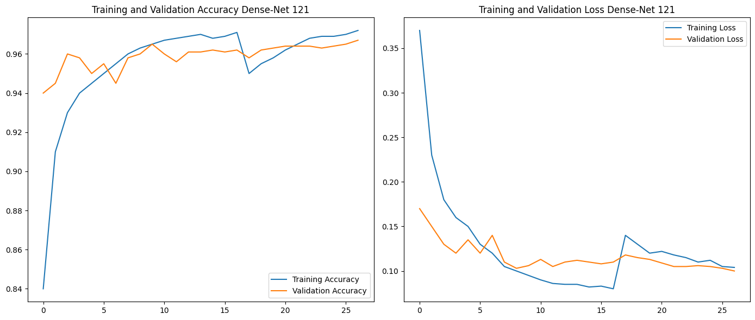

Figure 4.1: Learning curves for DenseNet121 SoftMax (two-phase fine-tuning). The transition between Phase 1 and Phase 2 is indicated by the dashed vertical line.

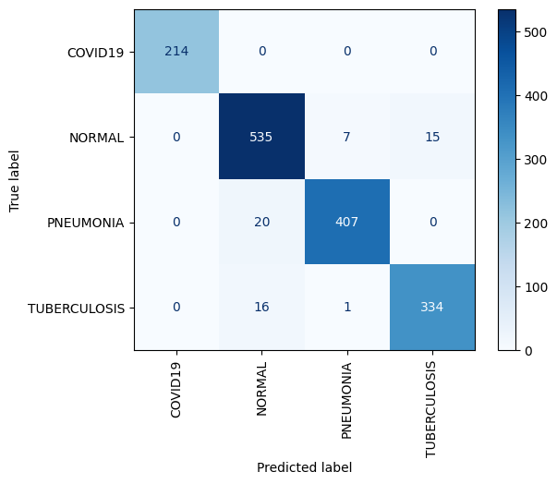

Figure 4.2: Confusion matrix for DenseNet121 SoftMax on the held-out test set. Diagonal entries represent correct predictions; off-diagonal entries indicate misclassification directions.
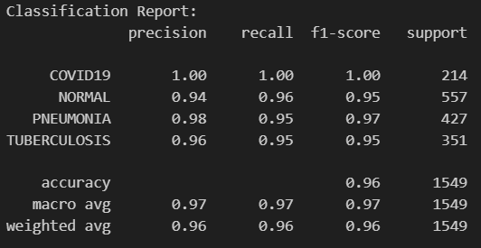

Figure 4.3: Per-class precision, recall, F1-score, and overall accuracy for DenseNet121 SoftMax on the test set.

4.2.3.2 — ResNet50V2 (Softmax, Partial Fine-Tuning)
The second SoftMax baseline employs ResNet50V2 (He et al., 2016, V2 with pre-activation residual blocks), a 50-layer residual network pre-trained on ImageNet. ResNet50V2 introduces significant architectural improvements over the original ResNet50, including full pre-activation order (BN → ReLU → Conv rather than Conv → BN → ReLU), which leads to improved gradient flow and training stability. The model follows a partial fine-tuning strategy in which the last 40 layers are unfrozen for task-specific adaptation while the earlier 100 layers retain their ImageNet representations.
The classification head follows the same structural template as DenseNet121: GAP → Dense(512, ReLU) → Dropout(0.4) → Dense(256, ReLU) → Dense(4, SoftMax). A notably lower learning rate of 1e-4 (is used from the outset, reflecting the more conservative fine-tuning approach appropriate for ResNet50V2's architecture. Training runs for a maximum of 30 epochs with early stopping (patience=7).
Table 4.7: ResNet50V2 SoftMax — Key Hyperparameters.
Parameter | Value
Base architecture | ResNet50V2 (ImageNet pre-trained)
Trainable layers | Last 40 layers of ResNet50V2 + classification head
Frozen layers | First ~145 layers
Optimizer | Adam (lr=1e-4)
Max epochs | 30
Loss | Sparse Categorical Cross-Entropy
Batch size | 32
Early stopping | patience=7, monitor=val_accuracy
LR reduction | ReduceLROnPlateau (factor=0.2, patience=3)
Class weights | Inverse-frequency (Table 4.5)
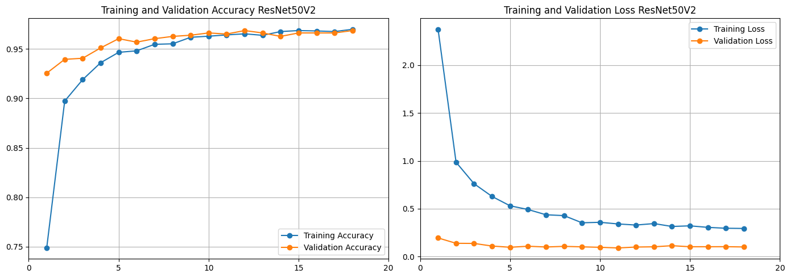
Figure 4.4: Learning curves for ResNet50V2 SoftMax over the training epochs.
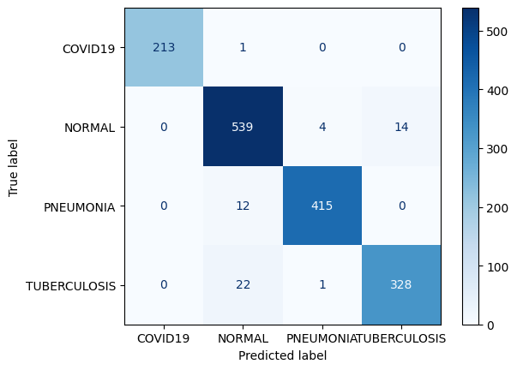
Figure 4.5: Confusion matrix for ResNet50V2 SoftMax on the held-out test set.

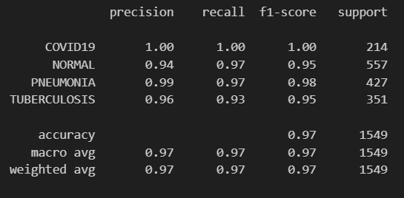

Figure 4.6: Per-class precision, recall, F1-score, and overall accuracy for ResNet50V2 SoftMax.

4.2.3.3 — EfficientNet (SoftMax)
EfficientNet scales network depth, width, and resolution jointly using a compound scaling coefficient, achieving state-of-the-art accuracy with fewer parameters than comparable architectures. The same classification head structure and training strategy are applied.
Table 4.8: EfficientNet SoftMax — Key Hyperparameters (to be completed).
Parameter | Value
Base architecture | [EfficientNetB0]
Pre-trained weights | [ImageNet]
Trainable layers | [ 200]
Optimizer | [Adam]
Learning rate | [1e-4]
Batch size | [32]
Max epochs | [30]
Loss | [Sparse Categorical Cross-Entropy]
Early stopping | [patience= 7, monitor= val_accuracy]
LR reduction | [ReduceLROnPlateau (factor=0.2, patience=3, min_lr=1e-7)]

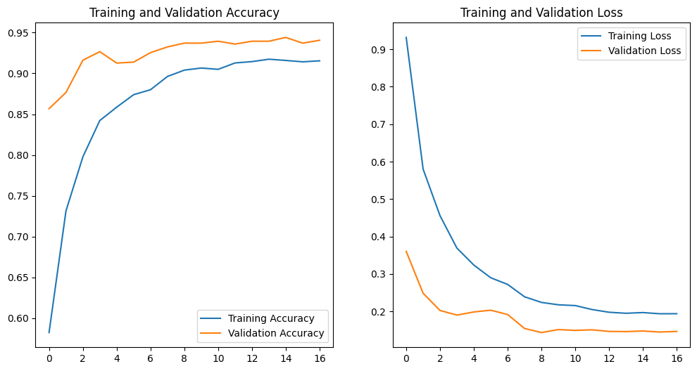

Figure 4.7: Learning curves for EfficientNet Softmax.
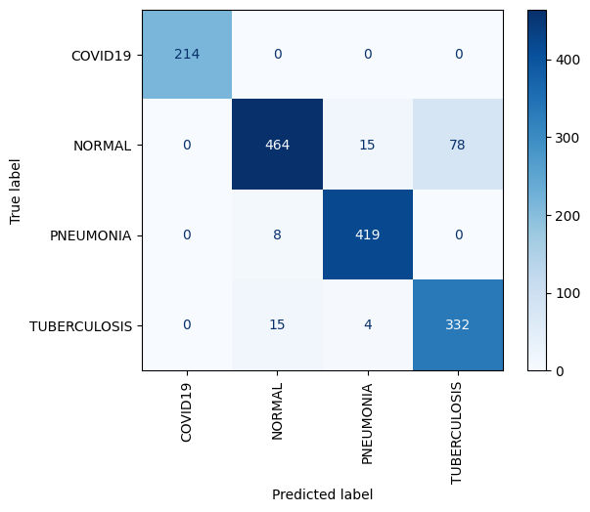

Figure 4.8: Confusion matrix for EfficientNet SoftMax on the test set.
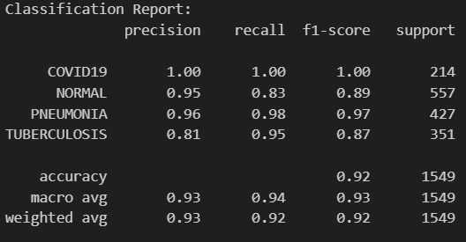

Figure 4.9: Per-class classification metrics for EfficientNet SoftMax.

4.2.3.4 — VGG-19 (SoftMax)
VGG-19 is a deep convolutional network with 19 weight layers characterized by a uniform architecture of $3×3$convolutions and max-pooling operations. Despite its comparatively large parameter count, it remains a strong baseline for medical image classification due to its simple and well-understood feature hierarchy.
Table 4.9: VGG-19 SoftMax — Key Hyperparameters (to be completed).
Parameter | Value
Base architecture | VGG-19 (ImageNet pre-trained)
Trainable layers | [e.g., last N convolutional/FC layers]
Optimizer | [ Adam]
Learning rate | [value]
Batch size | [value]
Max epochs | [value]
Loss | [Sparse Categorical Cross-Entropy]
Early stopping | [patience, monitor]
LR reduction | [factor, patience, min_lr]
[FIGURE 4.10 — VGG-19 Softmax: Learning Curves]
Training and validation accuracy/loss curves.
Figure 4.10: Learning curves for VGG-19 Softmax.
[FIGURE 4.11 — VGG-19 Softmax: Confusion Matrix]
4×4 confusion matrix heatmap (test set).
Figure 4.11: Confusion matrix for VGG-19 Softmax on the test set.
[FIGURE 4.12 — VGG-19 Softmax: Classification Report]
Precision, Recall, F1-Score, Accuracy per class.
Figure 4.12: Per-class classification metrics for VGG-19 Softmax.

4.2.4 One-vs-Rest Classification Results (OVR / Sigmoid Approach)
In the One-vs-Rest (OVR) paradigm, the four-class classification problem is decomposed into four independent binary classification sub-problems. Each output neuron $k$learns to distinguish class $k$from "all other classes" simultaneously. The output layer applies the sigmoid activation function independently to each logit, producing uncoupled probability scores:
$${\overset{^}{y}}_{k}=σ(z_{k})=\frac{1}{1+e^{-z_{k}}},k∈\{1,2,3,4\}$$(4.4)
A threshold of $τ=0.5$is applied to produce the predicted class: $\overset{^}{c}=arg⁡\max_{k}{\overset{^}{y}}_{k}$for single-label inference (the class with the highest sigmoid score is selected when exactly one prediction is required). The training loss is Binary Cross-Entropy computed independently per class and per sample:
$$L_{\text{OVR}}=-\frac{1}{NK}\sum_{n=1}^{N}{\sum_{k=1}^{K}{\left[y_{nk}log⁡{\overset{^}{y}}_{nk}+(1-y_{nk})log⁡(1-{\overset{^}{y}}_{nk})\right]}}$$(4.5)
Model selection is performed by monitoring the multi-label AUC-ROC metric on the validation set, rather than accuracy, because AUC is more informative for imbalanced multi-label settings.

4.2.4.1 — ResNet50 OVR (Sigmoid)
The ResNet50 OVR model uses ResNet50 (original V1 architecture) as the backbone, with the last 40 layers unfrozen for fine-tuning. This is a more targeted fine-tuning scope than the SoftMax ResNet50V2 variant, focusing on the highest-level residual blocks that encode the most abstract and class-discriminative representations. The classification head follows the OVR template: GAP → BN → Dense(512, ReLU) → Dropout(0.4) → Dense(256, ReLU) → Dropout(0.3) → Dense(4, Sigmoid).
Table 4.10: ResNet50 OVR — Key Hyperparameters.
Parameter | Value
Base architecture | ResNet50 (ImageNet pre-trained)
Trainable layers | Last 40 layers
Optimizer | Adam (lr=1e-4)
Max epochs | 40
Loss | Binary Cross-Entropy
Output activation | Sigmoid (independent per class)
Decision threshold | 0.5
Primary metric | AUC (multi-label)
Batch size | 32
Early stopping | patience=8, monitor=val_auc, mode=max
LR reduction | ReduceLROnPlateau (factor=0.2, patience=3, min_lr=1e-7, monitor=val_auc)
Model checkpoint | Monitor val_auc, save best only
Class weights | Inverse-frequency (Table 4.5)

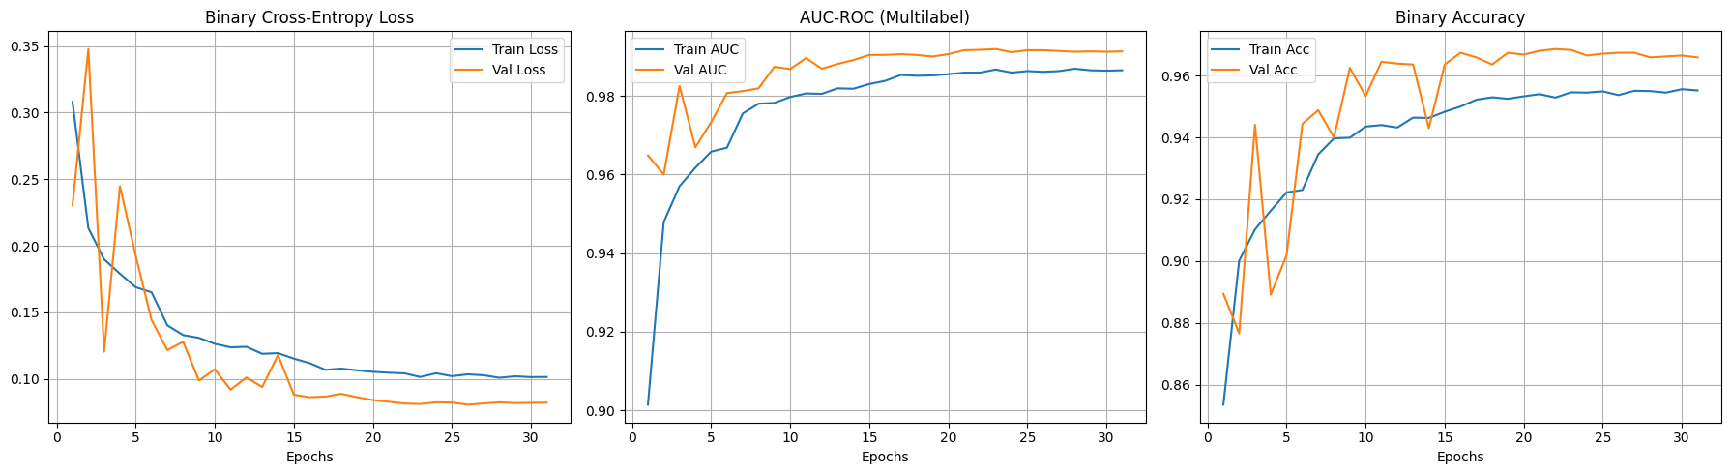
Figure 4.13: Learning curves for ResNet50 OVR (sigmoid) loss, AUC, and binary accuracy over training epochs.

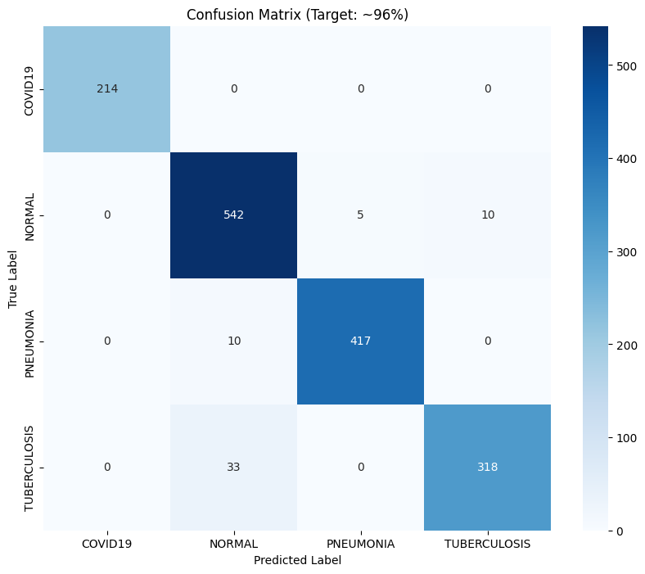

Figure 4.14: Confusion matrix for ResNet50 OVR on the held-out test set.

 | precision | recall | f1-score | support
COVID19 | 1.00 | 1.00 | 1.00 | 214
NORMAL | 0.93 | 0.97 | 0.95 | 557
PNEUMONIA | 0.99 | 0.98 | 0.98 | 427
TUBERCULOSIS | 0.97 | 0.91 | 0.94 | 351
accuracy |  |  | 0.96 | 1549
macro avg | 0.97 | 0.97 | 0.97 | 1549
weighted avg | 0.96 | 0.96 | 0.96 | 1549

Figure 4.15: Per-class precision, recall, F1-score, and AUC for ResNet50 OVR on the test set.

4.2.4.2 — DenseNet121 OVR (Sigmoid)
The DenseNet121 OVR model is the primary proposed classifier of this work and applies the full OVR formulation to the DenseNet121 backbone as described in Section 3.4.5.5. The last 100 layers of DenseNet121 are unfrozen, providing a broader fine-tuning scope that accommodates the dense connectivity pattern of DenseNet (where each layer is connected to all subsequent layers, meaning higher layers have access to features from much earlier in the network). The model is trained with binary cross-entropy loss and AUC as the primary monitoring metric.
Table 4.11: DenseNet121 OVR — Key Hyperparameters.
Parameter | Value
Base architecture | DenseNet121 (ImageNet pre-trained)
Trainable layers | Last 100 layers (base.layers[:-100] frozen)
Optimiser | Adam (lr=1e-4)
Max epochs | 40
Loss | Binary Cross-Entropy
Output activation | Sigmoid (independent per class)
Decision threshold | 0.5
Primary metric | AUC (multi-label)
Batch size | 32
Early stopping | patience=8, monitor=val_auc, mode=max
LR reduction | ReduceLROnPlateau (factor=0.2, patience=3, min_lr=1e-7)
Model checkpoint | densenet_ovr_best.h5 (monitor val_auc)
Class weights | Inverse-frequency (Table 4.5)

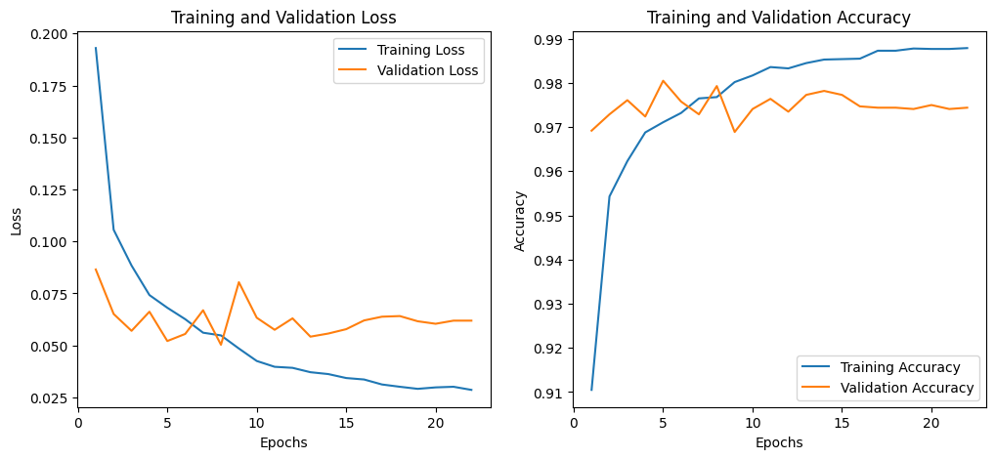
Figure 4.16: Learning curves for DenseNet121 OVR (sigmoid) — loss, and binary accuracy over training epochs.
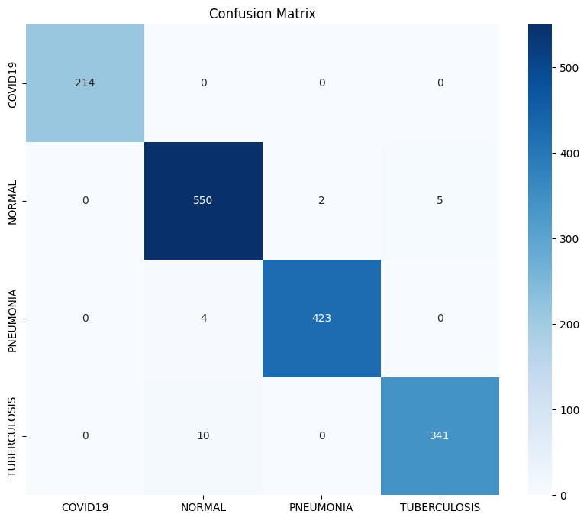

Figure 4.17: Confusion matrix for DenseNet121 OVR on the held-out test set.

 | precision | recall | f1-score | support
COVID19 | 1.00 | 1.00 | 1.00 | 214
NORMAL | 0.98 | 0.99 | 0.98 | 557
PNEUMONIA | 0.99 | 0.99 | 0.99 | 427
TUBERCULOSIS | 0.98 | 0.97 | 0.98 | 351
accuracy |  |  | 0.98 | 1549
macro avg | 0.99 | 0.99 | 0.99 | 1549
weighted avg | 0.98 | 0.98 | 0.98 | 1549

Figure 4.18: Per-class precision, recall, F1-score, and AUC for DenseNet121 OVR on the test set.

4.2.5 Federated Learning Results
Federated Learning (FL) is a distributed machine learning paradigm that enables model training across multiple decentralized data holders (clients) without requiring the centralized aggregation of raw data. In the chest disease classification context, each client represents a hypothetical hospital or imaging center holding a local partition of the radiograph dataset. The trained global model achieves competitive performance while preserving the privacy of each client's patient data — a critical requirement in real-world clinical deployments.

Federated Learning Framework and Architecture
The FL pipeline is implemented using the Flower (flwr) framework with a simulation-based execution model powered by the Ray distributed computing library. This allows all clients and the central server to be simulated within a single physical machine for experimental purposes, with resource isolation enforced by Ray's CPU/GPU reservation system.
The global model architecture is identical to the centralized DenseNet121 OVR model described in Section 3.4.5.5 — a DenseNet121 backbone with ImageNet pre-trained weights and a custom classification head. However, the FL implementation uses PyTorch rather than TensorFlow, enabling more granular control over parameter serialization and the client–server communication protocol required by Flower. Key aspects of the FL system are described below.

Data Partitioning Strategy
The global training set (15,229 images) is partitioned across $C$clients using a round-robin (interleaved) assignment strategy:
$$D_{i}=\{x_{j}:j≡i(modC),j∈\{0,1,…,N_{\text{train}}-1\}\}$$(4.6)
where $D_{i}$is the local dataset of client $i$, $C$is the total number of clients, and $N_{\text{train}}=15,229$. This produces approximately IID (Independent and Identically Distributed) data partition, since every $C$-th sample is assigned to the same client, preserving the overall class distribution within each client's local dataset. Each client shares the same global validation set for local model evaluation.

FedAvg Aggregation Strategy
Model updates from all clients are aggregated at the central server using the FedAvg (Federated Averaging) algorithm. At the end of each communication round $r$, the server receives updated model parameter vectors $\{w_{i}^{r}\}_{i=1}^{C}$from all $C$clients and computes the weighted average:
$$w^{r}=\sum_{i=1}^{C}{\frac{\left|D_{i}\right|}{N_{\text{train}}}}w_{i}^{r}$$(4.7)
Since the data partitioning is balanced (each client holds approximately $N_{\text{train}}/C$samples), the FedAvg reduces to a simple arithmetic mean: $w^{r}=\frac{1}{C}\sum_{i=1}^{C}{w_{i}^{r}}$. The aggregated global model $w^{r}$is then broadcast to all clients as the initialisation for the next round's local training.

Local Training Protocol
At each communication round, each client performs 3 local epochs of SGD-style training on its local partition before returning the updated parameters to the server. The local loss function is BCEWithLogitsLoss with class weights (computed identically to Equation 4.1 but from the full global training set, ensuring consistent weighting across all clients). The local optimizer is Adam with learning rate 1e-4, operating only on the classifier head parameters.

Global Early Stopping
A custom CustomFedAvg strategy extends Flower's standard FedAvg by implementing server-side global early stopping based on the aggregated validation loss across all clients. If the global validation loss fails to improve by at least $Δ=0.001$for 3 consecutive communication rounds, the simulation is terminated early, and the best global model weights are preserved. This prevents wasteful communication rounds after convergence and reduces the risk of overfitting to the training partitions.

Common Federated Learning Hyperparameters
Table 4.12: Common hyperparameters across all federated learning experiments (2, 3, and 4 clients).
Parameter | Value
Global model backbone | DenseNet121 (ImageNet pre-trained, PyTorch)
Trainable parameters | Last 100 parameters (classifier head)
Total communication rounds | 15 (maximum)
Local epochs per round | 3
Local batch size | 32
Local optimiser | Adam (lr=1e-4)
Local loss | BCEWithLogitsLoss (weighted)
Aggregation strategy | FedAvg (fraction_fit=1.0, fraction_evaluate=1.0)
Global early stopping | patience=3, min_delta=0.001
Data partitioning | Round-robin IID (interleaved indices)
Validation set | Shared global validation set (all clients)
Image preprocessing | Same CLAHE + Gaussian + normalisation pipeline
Augmentation (train) | RandomHorizontalFlip, RandomRotation(15°)
Normalization | mean=[0.485,0.456,0.406], std=[0.229,0.224,0.225]

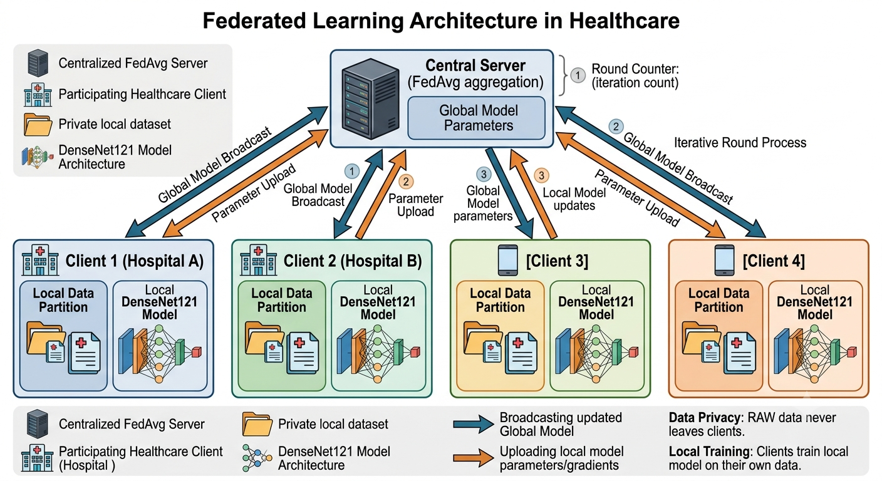

Figure 4.19: Federated Learning architecture for the proposed privacy-
preserving chest disease classification system. The central server aggregates local model updates via FedAvg without accessing raw patient data from any client.

4.2.5.1 — Federated Learning with 2 Clients
In the two-client scenario, the global training set is split equally between two clients, each holding approximately 7,615 images. The GPU fraction allocated per client is 0.5, ensuring that each client can leverage half of the available GPU memory for its local training.
Table 4.13: Two-client federated learning configuration.
Parameter | Value
Number of clients | 2
Training samples per client | ~7,615
GPU fraction per client | 0.5
CPUs per client | 1
Total Ray CPUs | 2
Total Ray GPUs | 1.0
Final Test Accuracy | 95.57%
With only two clients, each client's local dataset is the largest of all federated configurations (~50% of total training data), providing the richest local learning signal. The global model benefits from the full representational diversity of the dataset while still maintaining the privacy-preserving federated structure. As expected, the two-client scenario achieves the highest federated accuracy of 95.57%, demonstrating that competitive centralized performance can be approached through federated aggregation when each client holds a sufficiently large and representative local dataset.

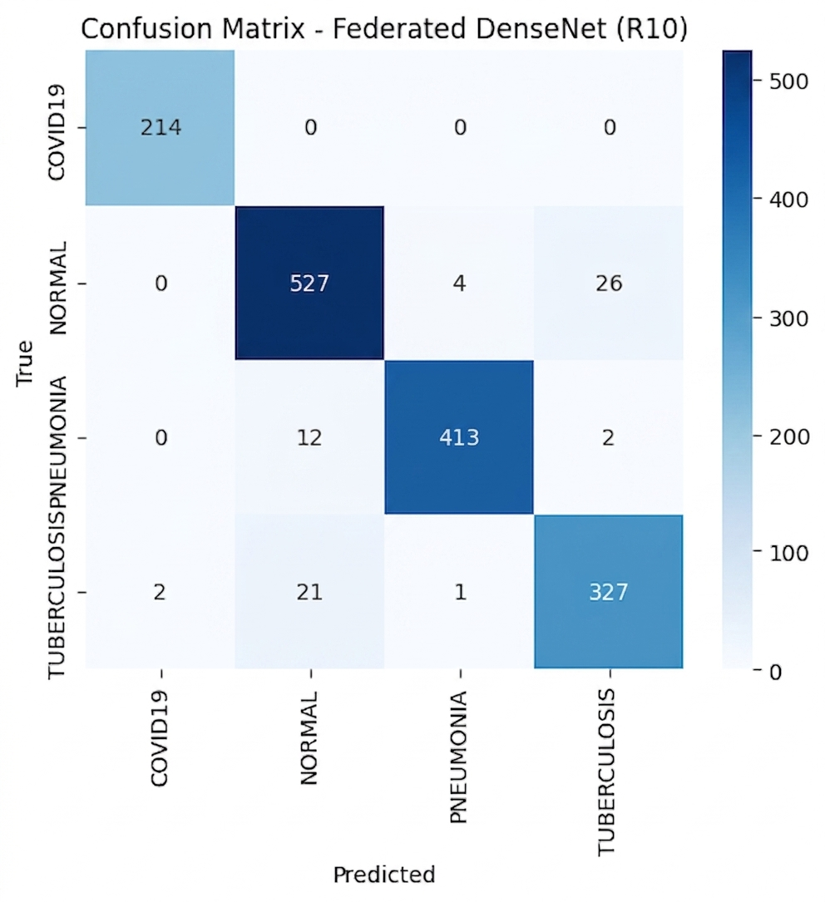

Figure 4.20: Confusion matrix for the Federated DenseNet121 model trained with 2 clients on the global held-out test set (accuracy: 95.57%).
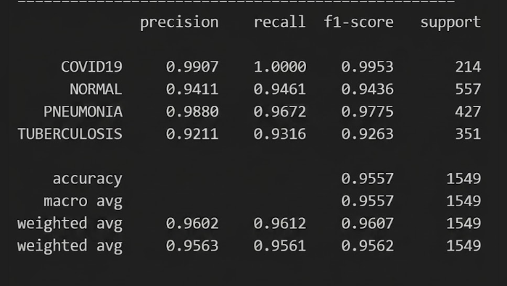

Figure 4.21: Per-class classification metrics for the Federated DenseNet121 model with 2 clients.

4.2.5.2 — Federated Learning with 3 Clients
In the three-client configuration, the global training data is distributed across three clients, each holding approximately 5,077 images (one-third of the total training set). The GPU fraction per client is reduced to 0.33 to accommodate the increased concurrency of three parallel simulation workers.
Table 4.14: Three-client federated learning configuration.
Parameter | Value
Number of clients | 3
Training samples per client | ~5,077
GPU fraction per client | 0.33
CPUs per client | 0.67
Total Ray CPUs | 2
Total Ray GPUs | 1.0
Final Test Accuracy | 94.13%
The three-client scenario represents a balanced compromise between privacy protection (data distribution across more nodes) and model performance. The test accuracy of 94.13% represents a modest decrease of 1.25 percentage points relative to the two-client scenario, reflecting the reduced local dataset size and the additional averaging noise introduced by aggregating three independent gradient trajectories. The FedAvg algorithm effectively compensates for this through the global parameter averaging, and the resulting model remains highly competitive with centralized baselines.

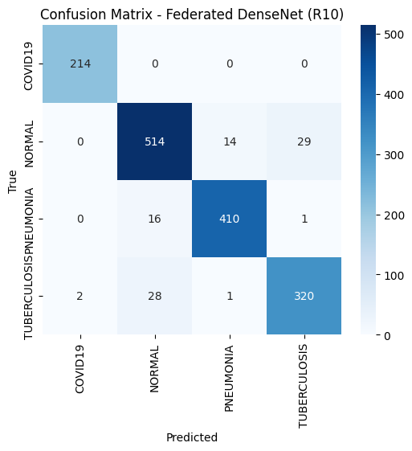

Figure 4.22: Confusion matrix for the Federated DenseNet121 model trained with 3 clients.
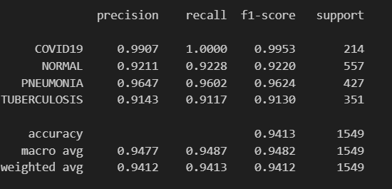

Figure 4.23: Per-class classification metrics for the Federated DenseNet121 model with 3 clients.

4.2.5.3 — Federated Learning with 4 Clients
The four-client configuration is the most extensively distributed scenario explored in this work, with the training set distributed across four clients holding approximately 3,807 images each. The GPU fraction per client is further reduced to 0.25. This represents a scenario representative of a small consortium of four collaborating hospitals, each contributing its local data to a jointly trained global model without sharing any patient records.
Table 4.15: Four-client federated learning configuration.
Parameter | Value
Number of clients | 4
Training samples per client | ~3,807
GPU fraction per client | 0.25
CPUs per client | 0.5
Total Ray CPUs | 2
Total Ray GPUs | 1.0
Final Test Accuracy | 93.22%
Despite each client holding only ~25% of the total training data, the four-client federated model achieves a test accuracy of 93.22% — a total decrease of 2.35 percentage points relative to the two-client scenario. This modest accuracy degradation confirms the robustness of the FedAvg aggregation strategy and demonstrates that the proposed system can maintain strong diagnostic performance even under the most distributed experimental configuration. The global early stopping mechanism plays a critical role in this scenario, preventing overfitting to the small local datasets.
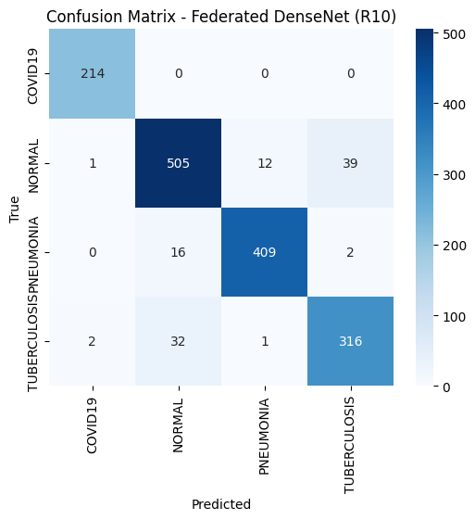

Figure 4.24: Confusion matrix for the Federated DenseNet121 model trained with 4 clients (accuracy: 93.22%).

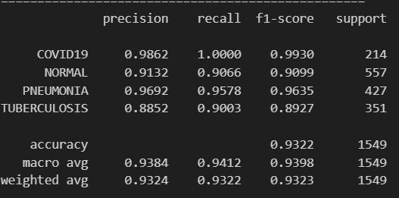

Figure 4.25: Per-class classification metrics for the Federated DenseNet121 model with 4 clients.

4.2.5.4 — Federated Learning Accuracy Comparison
Table 4.16 summarizes the test accuracy results across all three federated configurations, revealing a clear and consistent downward trend as the number of clients (and consequently the degree of data fragmentation) increases. This trend is consistent with the theoretical analysis of FedAvg convergence: with more clients holding smaller local datasets, the variance of local gradient estimates increases, requiring more communication rounds to converge to a solution of equivalent quality.
Table 4.16: Summary of federated learning test accuracy across client configurations.
Configuration | Clients | Images/Client | GPU/Client | Test Accuracy | Accuracy Drop vs. 2-Client
FL-2 | 2 | ~7,615 | 0.50 | 95.57% | —
FL-3 | 3 | ~5,077 | 0.33 | 94.13% | -1.44 pp
FL-4 | 4 | ~3,807 | 0.25 | 93.22% | -2.35 pp
A notable finding is that even the lowest-performing configuration (FL-4, 93.22%) remains a clinically viable classifier, demonstrating that federated learning can be deployed in practice without prohibitive accuracy losses when the global dataset is of sufficient size and the local partitions are IID. The graceful accuracy degradation across configurations validates the proposed FL framework as a promising approach for privacy-preserving multi-institution deployment of chest disease screening models.
Future work should investigate the impact of non-IID data partitioning — a more realistic scenario where different hospitals naturally hold different class distributions — and the use of more sophisticated FL strategies such as FedProx, SCAFFOLD, or personalized federated learning to mitigate the resulting performance degradation.

